Investigating why large ships float
and keys sink?

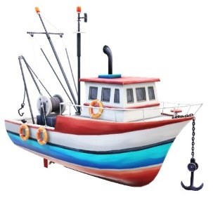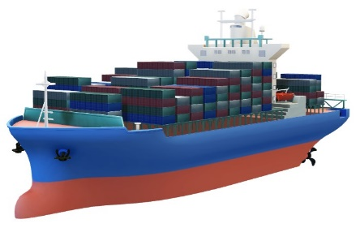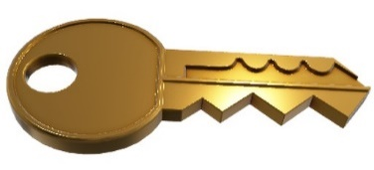

Did you ever wonder why a boat or a large ship can float in the ocean, and key would sink? Let’s investigate what things float, what things sink, and how this happens.
Key Words / Terms:
• Water Displacement • Density • Weight and Volume • Surface Area & Buoyancy
Helpful Points for Discussion:
- Water Displacement
The reason why objects float and sink depends the objects weight, compared to the weight of the water. Think about what happens when something is placed in water. It either floats or sinks. However, something also happens to the water.
An object and water can't be in the same space. When an object is placed into the water, the object pushes the water aside. This is called DISPLACEMENT.
For example if you were to put an ice cube into an full glass of water (right to the top), some water would spill out. The amount of water that spills out, is equal to the amount of space the ice cube takes up. This is the same if you were to hop into a bath that was full to the top. The amount of water that spills out, is equal to the space you took up in the bath.
- Density
What is Density? Try the experiments below and see what sinks and floats.
Dense objects usually have more molecules that are crowded close together. For example, a stone is more dense than an apple. Therefore, objects that are less dense are more likely to float. This is the case where the objects density weighs less than the water the object pushed aside.
- Volume & Weight
For water to be displaced by an object, we also need to understand how volume and weight affect objects.
Volume is the amount of space an object fills, or occupies. For example, a beach ball takes up the same space as a bowling ball, so they both have the same volume. However, the beach ball
weight is less than a bowling ball as it is fill mostly with air. Therefore, objects large in volume that hold a lot of air or open space usually float.
An object that has more air it is able to push more water aside than it weighs. Compare the weight of an apple and a paper clip, which one is the heaviest?
Predict which one will sink and which will float.
An apple floats because it has a greater volume, containing more air than the paperclip, even though it is heavier.
- Surface Area & Buoyancy:
The larger the surface area the object has for the force to push up on, the greater chance it will float. In addition, more water is displaced when the surface area of an object is large. This means the object it will also hold more weight.
For example, if you put a small bowl in the basin of water, it will float. The amount of water it is pushing aside weighs less than the bowl, so it is able to float. If you were to add some small stones in the bowl one at a time increasing its weight, the bowl will start to sink further into the water. Even though the bowl is heavier, it is able to push or displace the same weight of water to keep floating. If you keep adding objects to the bowl, it will be breached and will eventually sink.
Ships can float because they are designed to displace as much water as possible. They are designed so they are wide and the hull (bottom of the vessel) stretches down really far. This means the shape of the ship allows to push aside or displace a lot of water and remain floating.
Buoyancy is a force that pushes up on objects and provides objects the ability to float in a liquid. The shape the ship also allows a lot of empty or hollow space inside. This space helps to keep a ship light or buoyant in comparison to the huge amount of water that it is displacing.
Buoyancy is an important factor in the design of objects that are used at sea, such as fishing boats, container ships, research vessels and weather buoys. It is also important for submarines that come up to the ocean’s surface.
So with all of these things to consider, this is the reason why a ship can float and keys will sink in water.
Complete the following experiments to investigate will help to determine why a ship can float and keys sink.

- Experiment 1: Water Displacement
- Experiment 2: Density of Objects - Will it Sink or Float?
- Experiment 3: Volume & Weight – Which will Sink or Float?
- Experiment 4: Surface Area & Buoyancy

